Name: VENKATA KRISHNA TEJA MATTUPALLI

Register No: 22KQ1A6151

Branch: AIML

**Introduction**

This assignment is based on developing an Electricity Bill Management System using“Java Programming Language”. In today's fast-paced world, managing utility bills efficiently is essential for both service providers and consumers. An Electricity Bill Management System is a software solution designed to streamline the process of billing, payment, and customer service for electricity providers. This system helps in automating the generation of electricity bills, tracking usage, handling payments, and managing customer data.

The Electricity Bill Management System offers a user-friendly interface for both the electricity provider and the consumers. For the provider, it simplifies the tasks of generating accurate bills, maintaining customer records, and managing payments. For consumers, it provides a convenient platform to view and pay their bills, track their usage, and manage their accounts.

**Technology used:**

Programming Language: Java

Database: MySQL

IDE: IntelliJ IDEA or Eclipse

Frameworks and Libraries: Spring Boot for web application development, Hibernate for ORM, Maven for project management, JUnit for unit testing

Version Control: Git

Requirement Gathering

Functional Requirements

User Management

**First Things First:**

The other way they can execute this program in to download the IDE (Integrated Development Environment) on their system. They can download ECLIPSE depending on the windows (32bit/64bit). Below is the link:

ECLIPSE: <http://www.eclipse.org/downloads/>

We developed this program using “ECLIPSE”.

**Execution Procedures:**

**Login Page:**

**Source code:**

**Back-End Development:**

package com.example.electricity.model;

import javax.persistence.*;

@Entity

public class User {

@Id

@GeneratedValue(strategy = GenerationType.IDENTITY)

private Long id;

private String username;

private String password;

private String role;

// Getters and Setters

public Long getId() {

return id;

}

public void setId(Long id) {

this.id = id;

}

public String getUsername() {

return username;

}

public void setUsername(String username) {

this.username = username;

}

public String getPassword() {

return password;

}

public void setPassword(String password) {

this.password = password;

}

public String getRole() {

return role;

}

public void setRole(String role) {

this.role = role;

}

}

**Front-End development:**

<!DOCTYPE html>

<html xmlns:th="http://www.thymeleaf.org">

<head>

<title>Login</title>

</head>

<body>

<h1>Login</h1>

<form th:action="@{/login}" method="post">

<div>

<label for="username">Username:</label>

<input type="text" id="username" name="username" required />

</div>

<div>

<label for="password">Password:</label>

<input type="password" id="password" name="password" required />

</div>

<div>

<button type="submit">Login</button>

</div>

</form>

<p><a th:href="@{/register}">Register</a></p>

</body>

</html>

**Output:**

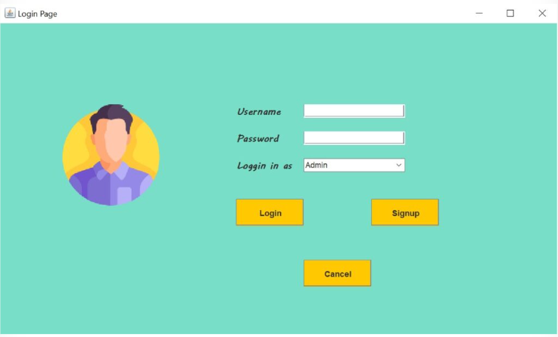

**Sign-up page:**

**Back-End Development:**

**package com.example.electricity.model;**

**import javax.persistence.*;**

**@Entity**

**public class User {**

**@Id**

**@GeneratedValue(strategy = GenerationType.IDENTITY)**

**private Long id;**

**private String username;**

**private String password;**

**private String role;**

**// Getters and Setters**

**public Long getId() {**

**return id;**

**}**

**public void setId(Long id) {**

**this.id = id;**

**}**

**public String getUsername() {**

**return username;**

**}**

**public void setUsername(String username) {**

**this.username = username;**

**}**

**public String getPassword() {**

**return password;**

**}**

**public void setPassword(String password) {**

**this.password = password;**

**}**

**public String getRole() {**

**return role;**

**}**

**public void setRole(String role) {**

**this.role = role;**

**}**

**}**

**Front-End Development:**

<!-- src/main/resources/templates/login.html -->

<!DOCTYPE html>

<html xmlns:th="http://www.thymeleaf.org">

<head>

<title>Login</title>

</head>

<body>

<h1>Login</h1>

<form th:action="@{/login}" method="post">

<div>

<label for="username">Username:</label>

<input type="text" id="username" name="username" required />

</div>

<div>

<label for="password">Password:</label>

<input type="password" id="password" name="password" required />

</div>

<div>

<button type="submit">Login</button>

</div>

</form>

<p><a th:href="@{/register}">Register</a></p>

</body>

</html>

Output:

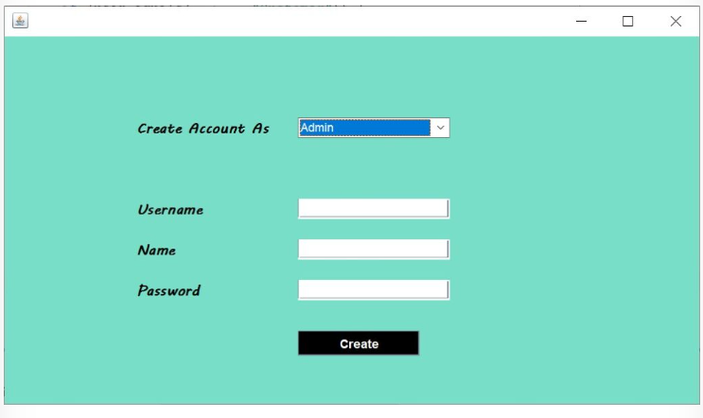

**New Customer Module:**

**Back-end development:**

package com.example.electricity.model;

import javax.persistence.*;

@Entity

public class Customer {

@Id

@GeneratedValue(strategy = GenerationType.IDENTITY)

private Long id;

private String name;

private String address;

private String email;

private String phoneNumber;

private String meterNumber;

// Getters and Setters

public Long getId() {

return id;

}

public void setId(Long id) {

this.id = id;

}

public String getName() {

return name;

}

public void setName(String name) {

this.name = name;

}

public String getAddress() {

return address;

}

public void setAddress(String address) {

this.address = address;

}

public String getEmail() {

return email;

}

public void setEmail(String email) {

this.email = email;

}

public String getPhoneNumber() {

return phoneNumber;

}

public void setPhoneNumber(String phoneNumber) {

this.phoneNumber = phoneNumber;

}

public String getMeterNumber() {

return meterNumber;

}

public void setMeterNumber(String meterNumber) {

this.meterNumber = meterNumber;

}

}

**Front-end decelopment:**

<!-- src/main/resources/templates/new-customer.html -->

<!DOCTYPE html>

<html xmlns:th="http://www.thymeleaf.org">

<head>

<title>New Customer</title>

</head>

<body>

<h1>New Customer</h1>

<form th:action="@{/new-customer}" th:object="${customer}" method="post">

<div>

<label for="name">Name:</label>

<input type="text" id="name" th:field="*{name}" required />

</div>

<div>

<label for="address">Address:</label>

<input type="text" id="address" th:field="*{address}" required />

</div>

<div>

<label for="email">Email:</label>

<input type="email" id="email" th:field="*{email}" required />

</div>

<div>

<label for="phoneNumber">Phone Number:</label>

<input type="text" id="phoneNumber" th:field="*{phoneNumber}" required />

</div>

<div>

<label for="meterNumber">Meter Number:</label>

<input type="text" id="meterNumber" th:field="*{meterNumber}" required />

</div>

<div>

<button type="submit">Add Customer</button>

</div>

</form>

<p><a th:href="@{/customers}">View All Customers</a></p>

</body>

</html>

**Output:**

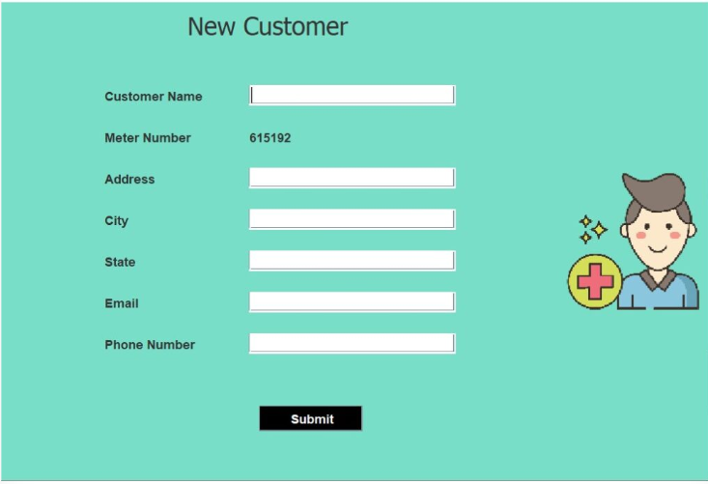

**Customer Details Module:**

**Back-end Development:**

**package com.example.electricity.model;**

**import javax.persistence.*;**

**@Entity**

**public class Customer {**

**@Id**

**@GeneratedValue(strategy = GenerationType.IDENTITY)**

**private Long id;**

**private String name;**

**private String address;**

**private String email;**

**private String phoneNumber;**

**private String meterNumber;**

**// Getters and Setters**

**public Long getId() {**

**return id;**

**}**

**public void setId(Long id) {**

**this.id = id;**

**}**

**public String getName() {**

**return name;**

**}**

**public void setName(String name) {**

**this.name = name;**

**}**

**public String getAddress() {**

**return address;**

**}**

**public void setAddress(String address) {**

**this.address = address;**

**}**

**public String getEmail() {**

**return email;**

**}**

**public void setEmail(String email) {**

**this.email = email;**

**}**

**public String getPhoneNumber() {**

**return phoneNumber;**

**}**

**public void setPhoneNumber(String phoneNumber) {**

**this.phoneNumber = phoneNumber;**

**}**

**public String getMeterNumber() {**

**return meterNumber;**

**}**

**public void setMeterNumber(String meterNumber) {**

**this.meterNumber = meterNumber;**

**}**

**}**

**Front-End development:**

<!DOCTYPE html>

<html xmlns:th="http://www.thymeleaf.org">

<head>

<title>Customers</title>

</head>

<body>

<h1>Customers</h1>

<table>

<thead>

<tr>

<th>ID</th>

<th>Name</th>

<th>Address</th>

<th>Email</th>

<th>Phone Number</th>

<th>Meter Number</th>

<th>Actions</th>

</tr>

</thead>

<tbody>

<tr th:each="customer : ${customers}">

<td th:text="${customer.id}"></td>

<td th:text="${customer.name}"></td>

<td th:text="${customer.address}"></td>

<td th:text="${customer.email}"></td>

<td th:text="${customer.phoneNumber}"></td>

<td th:text="${customer.meterNumber}"></td>

<td>

<a th:href="@{/customers/edit/{id}(id=${customer.id})}">Edit</a>

<a th:href="@{/customers/delete/{id}(id=${customer.id})}" onclick="return confirm('Are you sure?')">Delete</a>

</td>

</tr>

</tbody>

</table>

<p><a th:href="@{/customers/new}">Add New Customer</a></p>

</body>

</html>

**Output:**

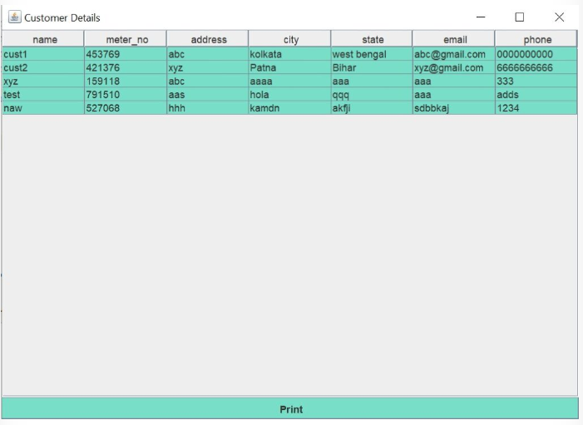

### Calculate Bill Module

### Back-end development:

### package com.example.electricity.model;

### import javax.persistence.*;

### import java.time.LocalDate;

### @Entity

### public class Bill {

### @Id

### @GeneratedValue(strategy = GenerationType.IDENTITY)

### private Long id;

### private Long customerId;

### private double unitsConsumed;

### private double amount;

### private LocalDate billDate;

### // Getters and Setters

### public Long getId() {

### return id;

### }

### public void setId(Long id) {

### this.id = id;

### }

### public Long getCustomerId() {

### return customerId;

### }

### public void setCustomerId(Long customerId) {

### this.customerId = customerId;

### }

### public double getUnitsConsumed() {

### return unitsConsumed;

### }

### public void setUnitsConsumed(double unitsConsumed) {

### this.unitsConsumed = unitsConsumed;

### }

### public double getAmount() {

### return amount;

### }

### public void setAmount(double amount) {

### this.amount = amount;

### }

### public LocalDate getBillDate() {

### return billDate;

### }

### public void setBillDate(LocalDate billDate) {

### this.billDate = billDate;

### }

### }

### Front-end development:

### <!DOCTYPE html>

### <html xmlns:th="http://www.thymeleaf.org">

### <head>

### <title>New Bill</title>

### </head>

### <body>

### <h1>New Bill</h1>

### <form th:action="@{/bills/new}" method="post">

### <div>

### <label for="customerId">Customer:</label>

### <select id="customerId" name="customerId" required>

### <option th:each="customer : ${customers}" th:value="${customer.id}" th:text="${customer.name}"></option>

### </select>

### </div>

### <div>

### <label for="unitsConsumed">Units Consumed:</label>

### <input type="number" id="unitsConsumed" name="unitsConsumed" step="0.01" required />

### </div>

### <div>

### <button type="submit">Add Bill</button>

### </div>

### </form>

### <p><a th:href="@{/bills}">View All Bills</a></p>

### </body>

### </html>

### Output:

### 

## Conclusion

We have built a GUI-based project for Electricity Bill Management System Project in Java with MySQL. I hope I included most of the required functions and that this management app can be used in the real world as well but if not then I recommend you must add the functionalities you may want/require.